1. Install pytest
   1. Open cmd and install pytest as >pip install -U pytest
   2. Check version >pytest --version
2. creating come calculator related functions and testing it
   1. create calculator.py and add following code
   2. create testing file for pytest
      1. remember, for pyetst, your file name must be either start or ends with test like
         1. test_calculator.py or calculator_test.py

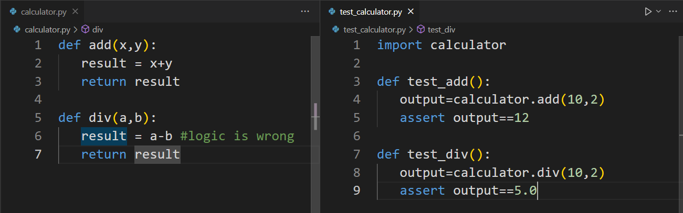

* 1. running test file :
     1. open cmd on folder location and run any of the following command

>pytest

>pytest -v (v for verbose)

>pytest -v -s (s to show message that we write in print)

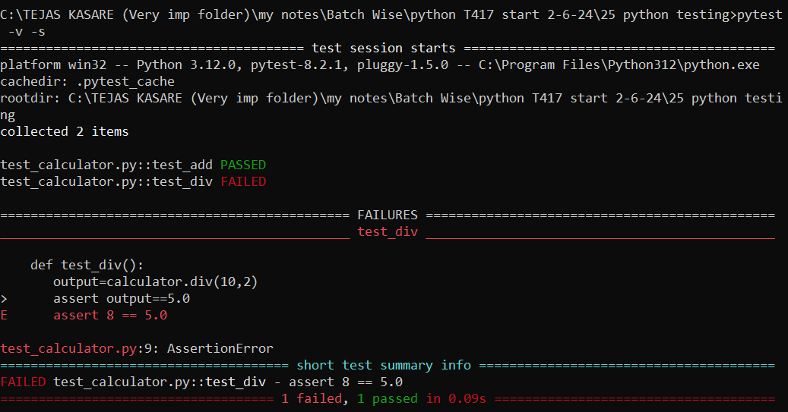

* 1. running test file with keywords
     1. create 2 more functions in test_calculator.py and run it as

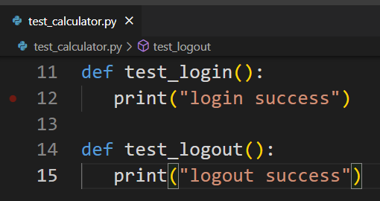

>pytest –vsk log

K for keyword and log is name of that keyword

1. running test file in group by using custom markers
   1. create one more file with test file

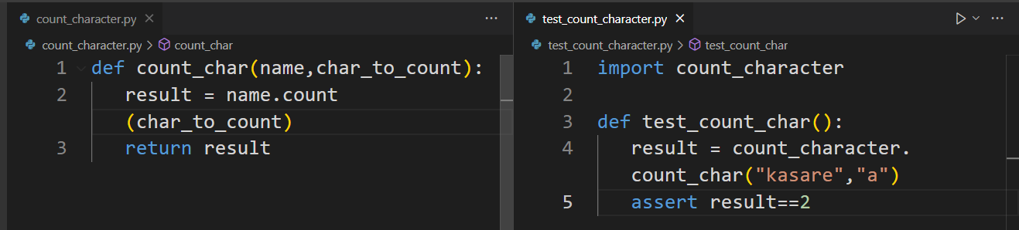

* 1. add custom markers on some functions in test_calcultor.py and test_count_character.py

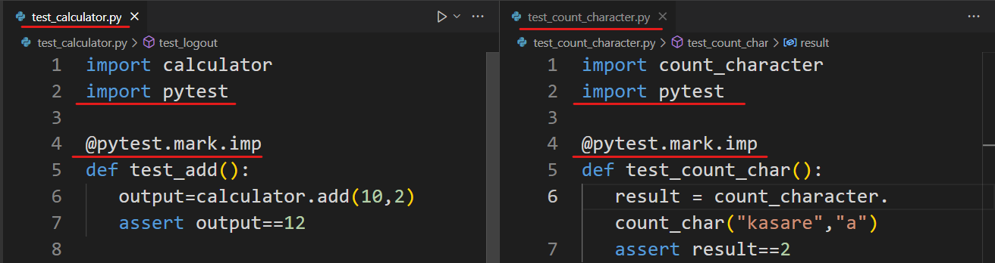

* 1. run test as >pytest -vsm imp

m for marker and imp is the name of marker

1. The Complete List Of Python Assert Statements :
   1. Click below link to get most common assert in pytest

https://understandingdata.com/posts/list-of-python-assert-statements-for-unit-tests/

1. fixture
   1. consider the following flow to test add to cart button :
      1. open browser ---------------------------

Arrange

* + 1. open website ----------------------------
    2. do login ------------------------------------
    3. click on add to cart button ------------ Action
    4. verify product is added to the cart-- Assert
    5. do logout ----------------------------------

Cleanup

* + 1. close browser ----------------------------

Arrange and cleanup together called as fixture

* 1. create test_addToCart.py and add following code

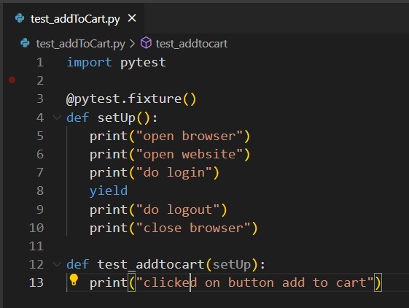

* 1. run it as > pytest test_addToCart.py –vs

1. DONE !!!!!!